SIL Verification Report
Project

Project ID: | 1
Customer: | —
Revision: | A
Date: | 2026-05-30

Automatically generated by SIL Verification Tool (Excel)

Contents
No table of contents entries found.

Purpose and Scope
This document summarizes the results of the conceptual design verification for the Safety Instrumented Functions (SIF) in the Project. The verification is performed in accordance with IEC 61511 / IEC 61508 using simplified equations for low demand mode of operation.
General Project Information
Project Identification: | 1
Project Name: | Project
Customer: | —
Project Description: | —
Analyst: | —
Reviewer: | —
Approver: | —
Revision: | A
Date: | 2026-05-30
Document Control
REV | DATE | APPROVED | DESCRIPTION OF CHANGE
A | 2026-05-30 | — | Initial issue

SIF-001 — SIL1 Low Pressure (254PI330|L1) nitrogen system, CO2 cleaning
SIF Overview
Target SIL 1 | Achieved SIL 2 |  | PFDavg 4,00E+00 |  | RRF 236 |  | FINAL ELEMENT
1oo1 | → |  | 1oo1 |  | → |  | 1oo2
General SIF Information
Analyst: | —
Analysis Date: | 30 May 2026
Design References: | —
Mission Time: | 15 years
Startup Time: | 24 hours
Demand Mode: | Low
Architectural Constraints: | IEC 61511
Consider Systematic Capability: | No
Consider MTTFS: | Yes
Site Safety Index: | Sensors: SSI 2 | LS: SSI 2 | FE: SSI 2
Comments: | —
Safety Integrity Levels
Target SIL: SIL 1 with RRF ≥ 10
Verification Result
PFDavg | RRF | Achieved SIL | Target met
4,00E+00 | 236 | 2 | YES
Subsystem Configurations
Sensor Part Configuration
Component |  |  |  | λNE
Endress+Hauser Cerabar S PMP71, PMP72 HT, PMP75 |  |  |  | 0,00E+00
PR Electronics 9106, 1 active in/1 active out |  |  |  | 0,00E+00
ABB AC800M High Integrity SIL2 [AnalogIn] |  |  |  | 0,00E+00
Proof Test Coverage [%]: |  |  |  | 97,5
β-factor [%]: |  |  |  | 0
ΣλDU [1/h]: |  |  |  | 0,00E+00
PFDavg: |  |  |  | 0,00E+00
Logic Solver Part Configuration
Component |  |  |  | λNE
Main Processor: PM865/PM867 with SM810/SM811/SM812 |  |  |  | 0,00E+00
Power Supply: SD823 + SS823 + MCB |  |  |  | 0,00E+00
Analog In Module: AI880A/TU844/845/TY801 |  |  |  | 0,00E+00
Channel: Analog In |  |  |  | 0,00E+00
Digital Out Module: DO880/TU842/843 |  |  |  | 0,00E+00
Channel: Digital Out |  |  |  | 0,00E+00
PFDavg: |  |  |  | 0,00E+00
Final Element Part Configuration
Component |  |  |  | λNE
ABB AC800M High Integrity SIL2 [DigitalOut] |  |  |  | 0,00E+00
Metso Norgren |  |  |  | 0,00E+00
Metso VPVL |  |  |  | 0,00E+00
Metso 7000 9000 |  |  |  | 0,00E+00
β-factor [%]: |  |  |  | 10
ΣλDU [1/h]: |  |  |  | 0,00E+00
PFDavg: |  |  |  | 2,00E+00
Diagrams
PFD Contribution per Subsystem
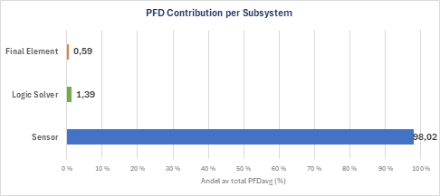
MTTFS Contribution per Subsystem
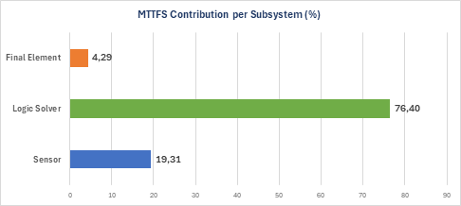
PFD vs Time (sawtooth)
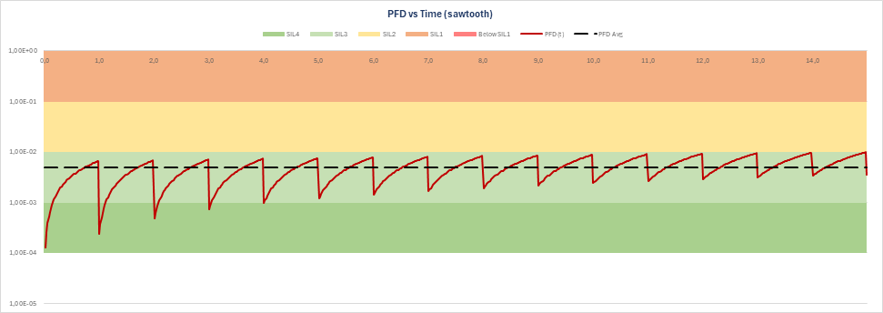

SIF-002 — SIL1 Low differential pressure (254PI330 / 347PI306) Nitrogen system
SIF Overview
Target SIL 1 | Achieved SIL 2 |  | PFDavg 6,00E+00 |  | RRF 160 |  | FINAL ELEMENT
2oo2 | → |  | 1oo1 |  | → |  | 1oo2
General SIF Information
Analyst: | —
Analysis Date: | 30 May 2026
Design References: | —
Mission Time: | 15 years
Startup Time: | 24 hours
Demand Mode: | Low
Architectural Constraints: | IEC 61511
Consider Systematic Capability: | No
Consider MTTFS: | Yes
Site Safety Index: | Sensors: SSI 2 | LS: SSI 2 | FE: SSI 2
Comments: | —
Safety Integrity Levels
Target SIL: SIL 1 with RRF ≥ 10
Verification Result
PFDavg | RRF | Achieved SIL | Target met
6,00E+00 | 160 | 2 | YES
Subsystem Configurations
Sensor Part Configuration
Component |  |  |  | λNE
Endress+Hauser Cerabar S PMP71, PMP72 HT, PMP75 |  |  |  | 0,00E+00
PR Electronics 9106, 1 active in/1 active out |  |  |  | 0,00E+00
ABB AC800M High Integrity SIL2 [AnalogIn] |  |  |  | 0,00E+00
Proof Test Coverage [%]: |  |  |  | 97,5
β-factor [%]: |  |  |  | 10
ΣλDU [1/h]: |  |  |  | 0,00E+00
PFDavg: |  |  |  | 0,00E+00
Logic Solver Part Configuration
Component |  |  |  | λNE
Main Processor: PM865/PM867 with SM810/SM811/SM812 |  |  |  | 0,00E+00
Power Supply: SD823 + SS823 + MCB |  |  |  | 0,00E+00
Analog In Module: AI880A/TU844/845/TY801 |  |  |  | 0,00E+00
Channel: Analog In |  |  |  | 0,00E+00
Digital Out Module: DO880/TU842/843 |  |  |  | 0,00E+00
Channel: Digital Out |  |  |  | 0,00E+00
PFDavg: |  |  |  | 0,00E+00
Final Element Part Configuration
Component |  |  |  | λNE
ABB AC800M High Integrity SIL2 [DigitalOut] |  |  |  | 0,00E+00
Metso Norgren |  |  |  | 0,00E+00
Metso VPVL |  |  |  | 0,00E+00
Metso 7000 9000 |  |  |  | 0,00E+00
β-factor [%]: |  |  |  | 10
ΣλDU [1/h]: |  |  |  | 0,00E+00
PFDavg: |  |  |  | 2,00E+00
Diagrams
PFD Contribution per Subsystem
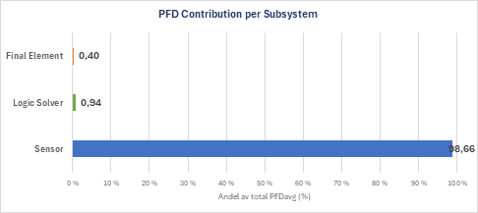
MTTFS Contribution per Subsystem

PFD vs Time (sawtooth)


SIF-003 — SIL1 High level (347LZ302) in Absorber (347YM100)
SIF Overview
Target SIL 1 | Achieved SIL 2 |  | PFDavg 1,00E+00 |  | RRF 777 |  | FINAL ELEMENT
1oo1 | → |  | 1oo1 |  | → |  | 1oo1
General SIF Information
Analyst: | —
Analysis Date: | 30 May 2026
Design References: | —
Mission Time: | 15 years
Startup Time: | 24 hours
Demand Mode: | Low
Architectural Constraints: | IEC 61511
Consider Systematic Capability: | No
Consider MTTFS: | Yes
Site Safety Index: | Sensors: SSI 2 | LS: SSI 2 | FE: SSI 2
Comments: | —
Safety Integrity Levels
Target SIL: SIL 1 with RRF ≥ 10
Verification Result
PFDavg | RRF | Achieved SIL | Target met
1,00E+00 | 777 | 2 | YES
Subsystem Configurations
Sensor Part Configuration
Component |  |  |  | λNE
Endress+Hauser Liquiphant M/S + FEL 58 |  |  |  | 0,00E+00
PR Electronics 9202, relay output |  |  |  | 0,00E+00
ABB AC800M High Integrity SIL2 [DigitalIn] |  |  |  | 0,00E+00
Proof Test Coverage [%]: |  |  |  | 92,2
β-factor [%]: |  |  |  | 0
ΣλDU [1/h]: |  |  |  | 0,00E+00
PFDavg: |  |  |  | 1,00E+00
Logic Solver Part Configuration
Component |  |  |  | λNE
Main Processor: PM865/PM867 with SM810/SM811/SM812 |  |  |  | 0,00E+00
Power Supply: SD823 + SS823 + MCB |  |  |  | 0,00E+00
Digital In Module: DI880/TU842/843 |  |  |  | 0,00E+00
Channel: Digitial In |  |  |  | 0,00E+00
Digital Out Module: DO880/TU842/843 |  |  |  | 0,00E+00
Channel: Digital Out |  |  |  | 0,00E+00
PFDavg: |  |  |  | 0,00E+00
Final Element Part Configuration
Component |  |  |  | λNE
ASC880 R2 STO |  |  |  | 0,00E+00
Proof Test Interval [Months]: |  |  |  | 12
MRT [Hours]: |  |  |  | 24
Proof Test Coverage [%]: |  |  |  | 90
β-factor [%]: |  |  |  | 0
ΣλDU [1/h]: |  |  |  | 0,00E+00
PFDavg: |  |  |  | 0,00E+00
Diagrams
PFD Contribution per Subsystem
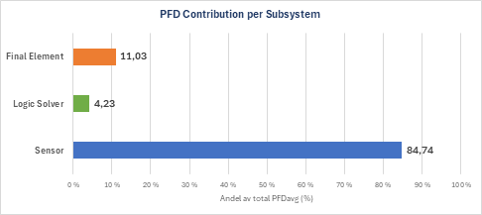
MTTFS Contribution per Subsystem
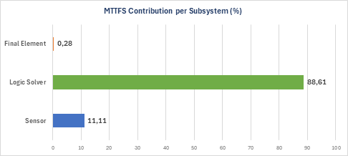
PFD vs Time (sawtooth)
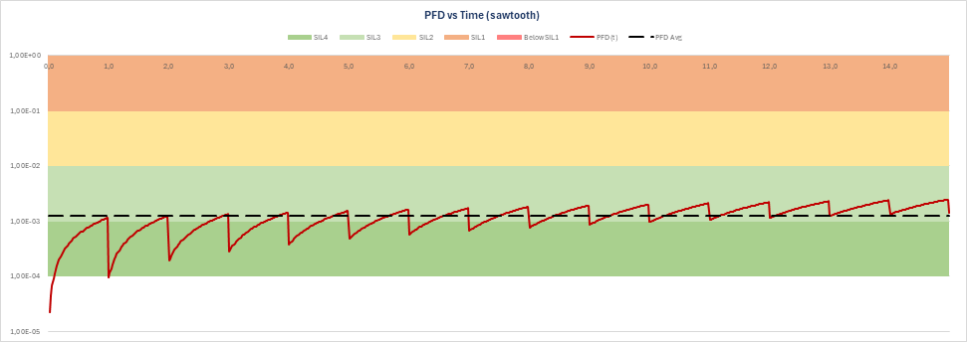

SIF-004 — SIL2 Low level (347LZ300) in Absorber (347YM100)
SIF Overview
Target SIL 2 | Achieved SIL 2 |  | PFDavg 6,00E+00 |  | RRF 150 |  | FINAL ELEMENT
1oo1 | → |  | 1oo1 |  | → |  | 1oo2
General SIF Information
Analyst: | —
Analysis Date: | 30 May 2026
Design References: | —
Mission Time: | 15 years
Startup Time: | 24 hours
Demand Mode: | Low
Architectural Constraints: | IEC 61511
Consider Systematic Capability: | No
Consider MTTFS: | Yes
Site Safety Index: | Sensors: SSI 2 | LS: SSI 2 | FE: SSI 2
Comments: | —
Safety Integrity Levels
Target SIL: SIL 2 with RRF ≥ 100
Verification Result
PFDavg | RRF | Achieved SIL | Target met
6,00E+00 | 150 | 2 | YES
Subsystem Configurations
Sensor Part Configuration
Component |  |  |  | λNE
Endress+Hauser Deltabar S PMD75, FMD77, FMD78 |  |  |  | 0,00E+00
PR Electronics 9106, 1 active in/1 active out |  |  |  | 0,00E+00
ABB AC800M High Integrity SIL2 [AnalogIn] |  |  |  | 0,00E+00
Proof Test Coverage [%]: |  |  |  | 91,9
β-factor [%]: |  |  |  | 0
ΣλDU [1/h]: |  |  |  | 0,00E+00
PFDavg: |  |  |  | 6,00E+00
Logic Solver Part Configuration
Component |  |  |  | λNE
Main Processor: PM865/PM867 with SM810/SM811/SM812 |  |  |  | 0,00E+00
Power Supply: SD823 + SS823 + MCB |  |  |  | 0,00E+00
Analog In Module: AI880A/TU844/845/TY801 |  |  |  | 0,00E+00
Channel: Analog In |  |  |  | 0,00E+00
Digital Out Module: DO880/TU842/843 |  |  |  | 0,00E+00
Channel: Digital Out |  |  |  | 0,00E+00
PFDavg: |  |  |  | 0,00E+00
Final Element Part Configuration
Component |  |  |  | λNE
ABB AC800M High Integrity SIL2 [DigitalOut] |  |  |  | 0,00E+00
Metso Norgren |  |  |  | 0,00E+00
Metso VPVL |  |  |  | 0,00E+00
Metso 7000 9000 |  |  |  | 0,00E+00
β-factor [%]: |  |  |  | 10
ΣλDU [1/h]: |  |  |  | 0,00E+00
PFDavg: |  |  |  | 2,00E+00
Diagrams
PFD Contribution per Subsystem
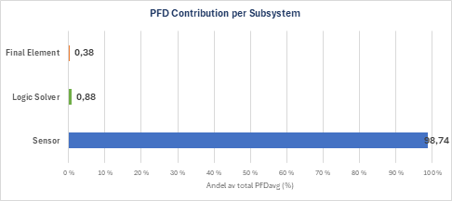
MTTFS Contribution per Subsystem

PFD vs Time (sawtooth)
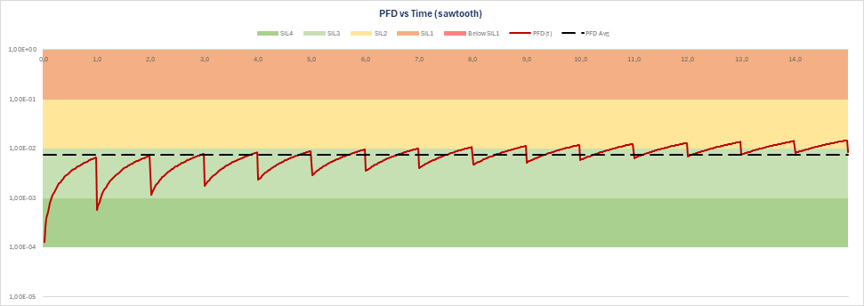

SIF-005 — SIL1 High level (347LS305) filter separator 347SE101 stop 346PU101
SIF Overview
Target SIL 1 | Achieved SIL 2 |  | PFDavg 1,00E+00 |  | RRF 810 |  | FINAL ELEMENT
1oo1 | → |  | 1oo1 |  | → |  | 1oo1
General SIF Information
Analyst: | —
Analysis Date: | 30 May 2026
Design References: | —
Mission Time: | 15 years
Startup Time: | 24 hours
Demand Mode: | Low
Architectural Constraints: | IEC 61511
Consider Systematic Capability: | No
Consider MTTFS: | Yes
Site Safety Index: | Sensors: SSI 2 | LS: SSI 2 | FE: SSI 2
Comments: | —
Safety Integrity Levels
Target SIL: SIL 1 with RRF ≥ 10
Verification Result
PFDavg | RRF | Achieved SIL | Target met
1,00E+00 | 810 | 2 | YES
Subsystem Configurations
Sensor Part Configuration
Component |  |  |  | λNE
Endress+Hauser Liquiphant M/S + FEL 58 |  |  |  | 0,00E+00
PR Electronics 9202, relay output |  |  |  | 0,00E+00
ABB AC800M High Integrity SIL2 [DigitalIn] |  |  |  | 0,00E+00
Proof Test Coverage [%]: |  |  |  | 91,9
β-factor [%]: |  |  |  | 0
ΣλDU [1/h]: |  |  |  | 0,00E+00
PFDavg: |  |  |  | 1,00E+00
Logic Solver Part Configuration
Component |  |  |  | λNE
Main Processor: PM865/PM867 with SM810/SM811/SM812 |  |  |  | 0,00E+00
Power Supply: SD823 + SS823 + MCB |  |  |  | 0,00E+00
Digital In Module: DI880/TU842/843 |  |  |  | 0,00E+00
Channel: Digitial In |  |  |  | 0,00E+00
Digital Out Module: DO880/TU842/843 |  |  |  | 0,00E+00
Channel: Digital Out |  |  |  | 0,00E+00
PFDavg: |  |  |  | 0,00E+00
Final Element Part Configuration
Component |  |  |  | λNE
ASC880 R2 STO |  |  |  | 0,00E+00
Proof Test Interval [Months]: |  |  |  | 12
MRT [Hours]: |  |  |  | 24
Proof Test Coverage [%]: |  |  |  | 99
β-factor [%]: |  |  |  | 0
ΣλDU [1/h]: |  |  |  | 0,00E+00
PFDavg: |  |  |  | 0,00E+00
Diagrams
PFD Contribution per Subsystem
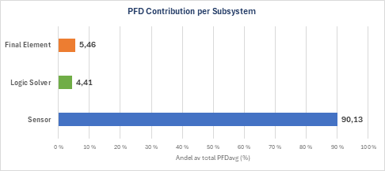
MTTFS Contribution per Subsystem

PFD vs Time (sawtooth)
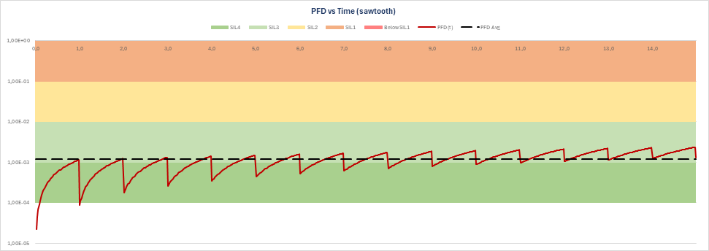

SIF-006 — New SIF — edit description
SIF Overview
Target SIL 2 | Achieved SIL 2 |  | PFDavg 1,00E+00 |  | RRF 810 |  | FINAL ELEMENT
1oo1 | → |  | 1oo1 |  | → |  | 1oo1
General SIF Information
Analyst: | —
Analysis Date: | 30 May 2026
Design References: | —
Mission Time: | 15 years
Startup Time: | 24 hours
Demand Mode: | Low
Architectural Constraints: | IEC 61511
Consider Systematic Capability: | No
Consider MTTFS: | Yes
Site Safety Index: | Sensors: SSI 2 | LS: SSI 2 | FE: SSI 2
Comments: | —
Safety Integrity Levels
Target SIL: SIL 2 with RRF ≥ 100
Verification Result
PFDavg | RRF | Achieved SIL | Target met
1,00E+00 | 810 | 2 | YES
Subsystem Configurations
Sensor Part Configuration
Component |  |  |  | λNE
Endress+Hauser Liquiphant M/S + FEL 58 |  |  |  | 0,00E+00
PR Electronics 9202, relay output |  |  |  | 0,00E+00
ABB AC800M High Integrity SIL2 [DigitalIn] |  |  |  | 0,00E+00
Proof Test Coverage [%]: |  |  |  | 91,9
β-factor [%]: |  |  |  | 0
ΣλDU [1/h]: |  |  |  | 0,00E+00
PFDavg: |  |  |  | 1,00E+00
Logic Solver Part Configuration
Component |  |  |  | λNE
Main Processor: PM865/PM867 with SM810/SM811/SM812 |  |  |  | 0,00E+00
Power Supply: SD823 + SS823 + MCB |  |  |  | 0,00E+00
Digital In Module: DI880/TU842/843 |  |  |  | 0,00E+00
Channel: Digitial In |  |  |  | 0,00E+00
Digital Out Module: DO880/TU842/843 |  |  |  | 0,00E+00
Channel: Digital Out |  |  |  | 0,00E+00
PFDavg: |  |  |  | 0,00E+00
Final Element Part Configuration
Component |  |  |  | λNE
ASC880 R2 STO |  |  |  | 0,00E+00
Proof Test Interval [Months]: |  |  |  | 12
MRT [Hours]: |  |  |  | 24
Proof Test Coverage [%]: |  |  |  | 99
β-factor [%]: |  |  |  | 0
ΣλDU [1/h]: |  |  |  | 0,00E+00
PFDavg: |  |  |  | 0,00E+00
Diagrams
PFD Contribution per Subsystem

MTTFS Contribution per Subsystem
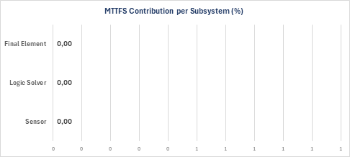
PFD vs Time (sawtooth)


Disclaimer, Assumptions, Equipment Data
Disclaimer
The results shown in this SIL verification Report are based on the design data, failure rates and proof test parameters provided. Accuracy of the result is dependent on the accuracy of the input data.
Assumptions
Low demand mode of operation per IEC 61511-1.
- Simplified PFD equations per IEC 61508-6, Annex B.
- Constant failure rate (exponential distribution).
- Common cause modeled via β-factor (Beta model).
- Single-leg / single-group per subsystem (sum of component λ-values).
- Architectural constraints (Route 1H/2H, SFF, HFT) not automatically verified.
- Verification Status
This tool has been validated against the Hybrit Pilot Plant SILver Detailed Report (24 Apr 2022, exSILentia v4.12.2). For SIF-001 through SIF-005, the achieved SIL classification matches in 5 of 5 cases. The geometric mean PFD ratio (Tool / Report) is 1.84×.

